Apache arrow is a cross language in-memory data format designed to

The way how it

Every framework will hit the data and fetch from db, but

Here the way how apache arrow fetches and stores in RAM is different than other frameworks as below

Language agnostic standard for columnar memory

Efficient for running large analytical workloads on modern cpu architecture

Querying the large data sets

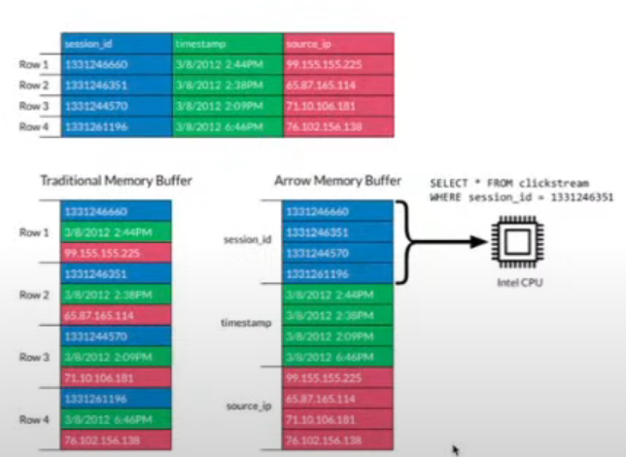

Apache arrow is a new client server protocol developed by apache ( which internally uses arrow in-memory columnar format )

for interacting with SQL databases

|  |  |
| --- | --- |
| **Arrow flight**  **to transfer high volume of columnar data**  good for distributed computing and analytics | Arrow flight SQL  Provides SQL interface for arrow flight  Exec query and returns columnar format |
|  |  |